**Table of Contents**

1. **Personal Information**
   1. Resume
   2. Cover Letter
   3. Evidence for Academic Achievement
      1. Report Cards
2. **SciTech Skills and Knowledge and Certifications**
   1. Euclid/CSMC/Chem13 Competitions
   2. Physics Egg Drop
   3. Audio Amplifier
3. **Community Work and Extracurricular Involvement**
   1. The 6ix Robotics
4. **SciTech Extracurricular Experiences**
   1. PCHackers 2019

# Physics Egg Drop

In Grade 12 Physics we were tasked with developing a system that would prevent an egg from cracking at a fall of 6 feet. We were told we could use nearly any materials just the egg had to fall from 6 feet and reach the ground in a freefall. Me and Alex spent many hours developing and planning different ideas to maximize the height at which we could drop our egg. We wanted for the egg to not only survive 6 feet but also survive heights well above that. We went through numerous idea revisions and did dozens of tests until we settled on our final design. Our design was made of two components the drag and the crumple zone. The drag feature on our device prevented the egg from reaching a terminal velocity, it added drag. Many teams used a parachute but for us in practice we found the parachute took too long to deploy so we created tight wings which would cause drag immediately compared to a parachute which must go from loose to tight over a period of time. For our crumple zone we tested many different materials, the crumple zone in essence is a cushioning material which elongates the time that the egg is impacting the ground thus lowering the impulse effect on the egg. The final material choice we used for our egg drop was a special type of foam used to hold fragile glass in cases, this foam was very compressible and soft which meant that the egg rather then bouncing off would compress the foam thus spreading out the time of impact. This project was a fantastic experience which allowed my team to use our physics and engineering skills to solve a real world application in a fun way.

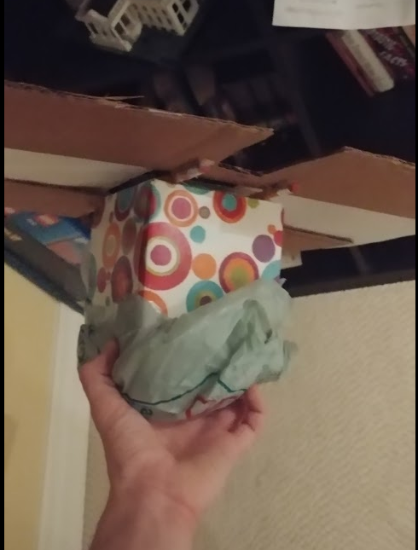



# Audio Amplifier

Mr. Whatley came back to teach more electrical engineering principles to the Grade 12 Computer Engineering class. This in time in contrast to the Voltage Regulator, the project we would be building is an audio amplifier. Mr Whatley took us through the steps of the Audio Amplifier just like the Voltage Regulator. We went from the audio input through the transistor amplifier and to the speaker circuit. This was another fantastic demonstration which taught me so much in an engaging format. I was able to learn the principles of transistor amplifiers and audio signals while also getting the satisfaction of creating a fun device. This project was also a great introduction to the advanced topics we would have to focus on after this project. After the completion of the project we segwayed into operational amplifiers, operational amplifiers are incredibly complex devices and the information we learned from soldering the audio amplifier was incredibly helpful.

# 

**PCHacks 2019**

I joined PCHackers immediately after the PCHack Day I participated in 2018 as I was excited to plan and create a hackathon. Over the summer we planned out PCHackers as an organization, we decided that PCHackers is not only an organization for planning hackathons but also an educational one.

In the summer I taught programming courses to little children, including teaching them how to program in python and programming an Amazon Alexa to have custom commands. In the school year I hosted workshops teaching Port Credit students to program as well.

Our goal for the 2019 hackathon was to create Canada’s Largest High School student run hackathon. As an executive of this team I have been working on planning the hackathon mainly on the logistics side including scheduling, volunteers, sponsorships and guest speakers. Throughout the summer we decided our main priority was to find a venue as the hackathon experience is all dependent on the quality of the venue. We approached many companies and schools including Sheridan college and BMO HQ however in the end we decided to choose the University of Toronto Mississauga campus, due to its open campus, cost effective space and new architecture. We have spent since the beginning of June planning for this 24 hour hackathon which happened on May 4th and 5th. We had to raise over $10,000 as we had to pay for the UTM venue for 24 hours, pay for prizes and provide food to over 250 people over a 24 hour period. Through a collection of sponsors we raised enough money to make this hackathon a reality. The event was a massive success, we had a massive turnout and truly hit the status of Canada’s largest high school student run hackathon. We had a number of highly qualified engineers and industry professionals as well as a member of parliament Iqra Khalid. It was a fantastic experience seeing a project go from the idea phase all the way to a massive event. I learned so much from planning and running this, but most importantly I developed connections which a group of amazing individuals which I will never forget.

